

**Computer Architecture**

LAB#2

**Designing Logic Circuits**

**Urba Naseem-52920**

BS-CS 4

Submitted to:

Ma’am Ayesha Akram

**Date:** 19th February,2025

**Task 1:**

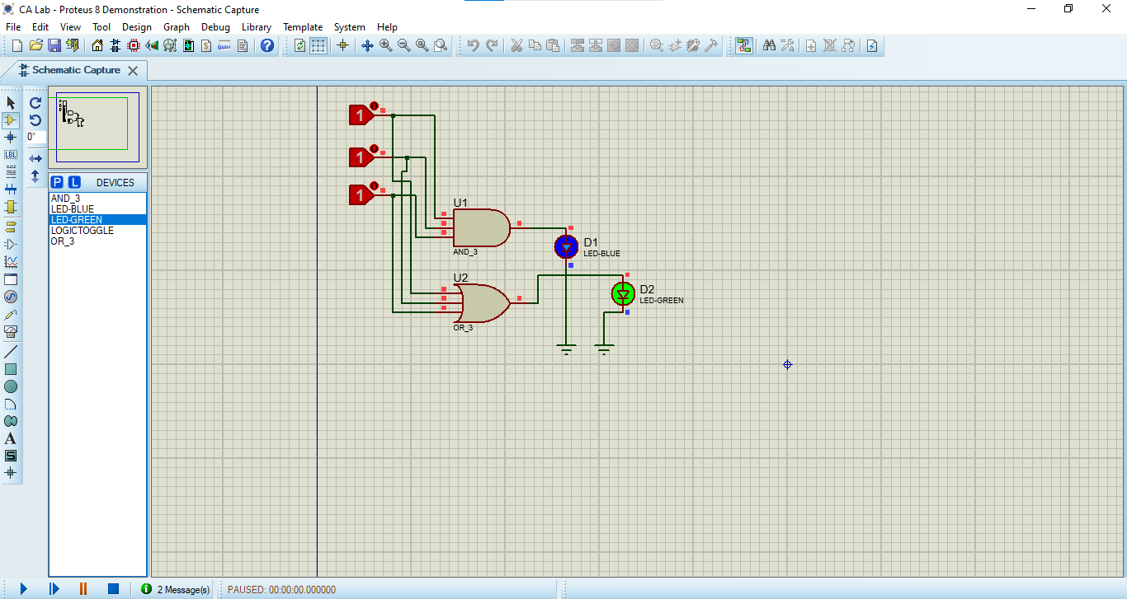

**Task 2:**

